Grey level Transformations:
Code:
import cv2
import numpy as np
image = cv2.imread('dag.jpg')
if image is None:
exit()
gray_image = cv2.cvtColor(image, cv2.COLOR_BGR2GRAY)
negative_image = 255 - gray_image
c = 255 / np.log(1 + np.max(gray_image))
log_image = c * np.log(1 + gray_image)
log_image = np.array(log_image, dtype=np.uint8)
gamma = 1.5
c = 255 / np.max(gray_image) ** gamma
power_law_image = c * (gray_image ** gamma)
power_law_image = np.array(power_law_image, dtype=np.uint8)
cv2.imshow('Original Image', image)
cv2.imshow('Negative Transformation', negative_image)
cv2.imshow('Log Transformation', log_image)
cv2.imshow('Power-Law Transformation', power_law_image)
cv2.waitKey(0)
cv2.destroyAllWindows()

Code Explanation:
- The image 'dag.jpg' is loaded and converted to grayscale.
- Three grey-level transformations are applied:
  - Negative Transformation: The pixel values are subtracted from 255, creating a negative of the grayscale image.
  - Logarithmic Transformation: A logarithmic function is applied to enhance the darker regions, making them more visible.
  - Power-Law (Gamma) Transformation: A power-law function is applied with γ=1.5\gamma = 1.5γ=1.5, making the darker regions lighter while keeping the bright areas unchanged.
- The transformed images are displayed alongside the original.
Output:
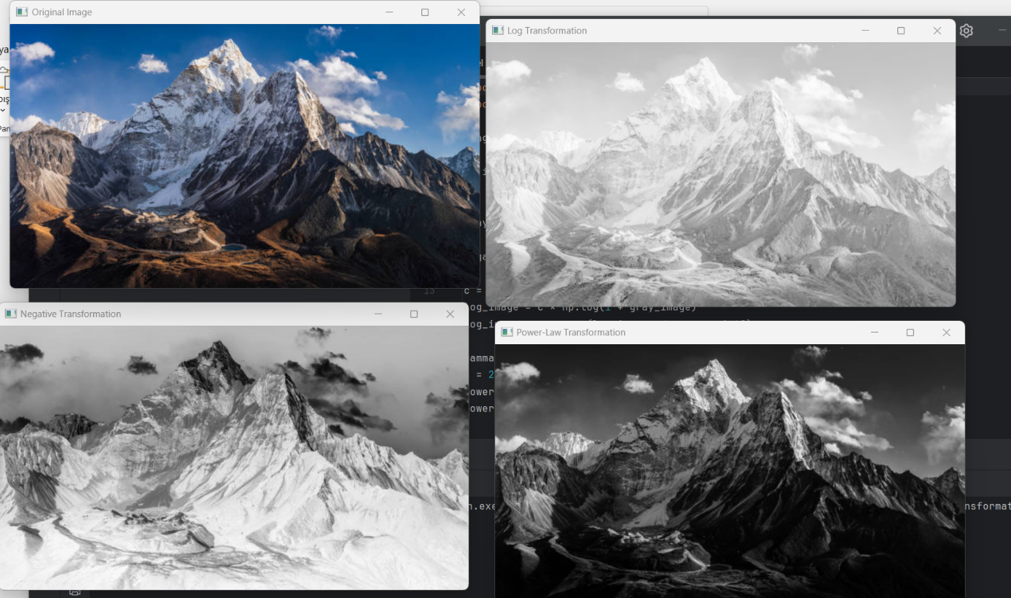

Report:
This code applies grey-level transformations to an image to adjust its contrast and brightness. The three transformations used are:
- Negative Transformation: The intensity of each pixel is inverted, which results in an image where bright regions become dark and vice versa. This is useful for emphasizing details in dark areas of the image.
- Logarithmic Transformation: This transformation enhances the lower intensity values, making the details in darker regions more visible. It is often used to process images with low contrast or to correct for underexposure.
- Power-Law (Gamma) Transformation: This transformation adjusts the image brightness according to a power law. For γ>1\gamma > 1γ>1, the dark regions are brightened, and for γ<1\gamma < 1γ<1, the bright regions are darkened. In this case, γ=1.5\gamma = 1.5γ=1.5 enhances the dark regions while keeping the bright regions relatively unchanged.
These transformations are commonly used in various image processing applications, including contrast adjustment, image enhancement, and feature highlighting.

